

FATIMA JINNAH WOMEN UNIVERSITY
RAWALPINDI
Department Of Software Engineering

Cloud Computing Lab
Saira Ejaz [2023-BSE-057]
Section: 5-B
LAB NO 9

Codespaces + AWS: GH CLI (Codespaces), AWS CLI, EC2, IAM, Security Groups, Filters & Queries
Lab Tasks:
Task 1 — GitHub CLI, Codespace setup and authentication
- Local desktop) Install GitHub CLI (Windows example via winget):
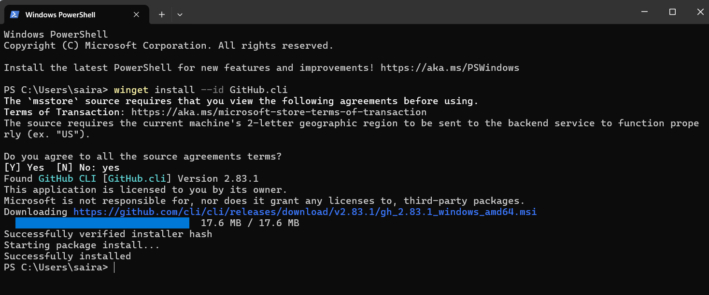
- (Local) Authenticate GH CLI for Codespaces:
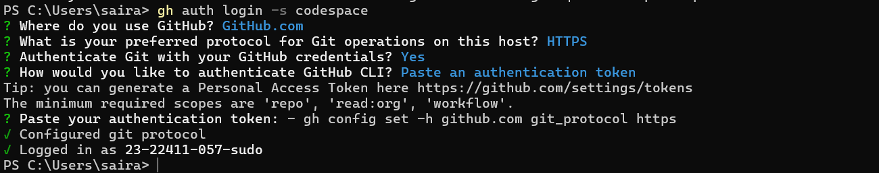

- (Local) List available Codespaces (optional verification):
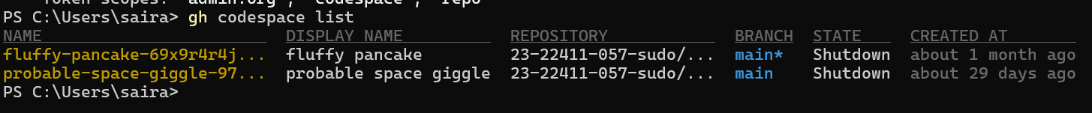
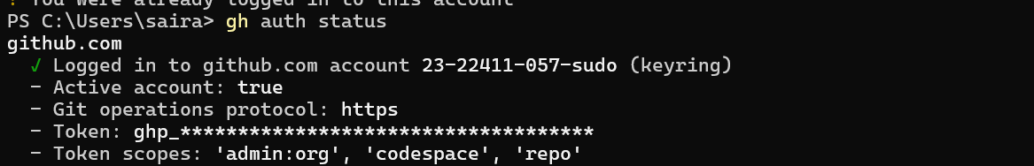
- (Local) Create or connect to a Codespace. To create a new codespace from the current repo:
Or to open an existing codespace:
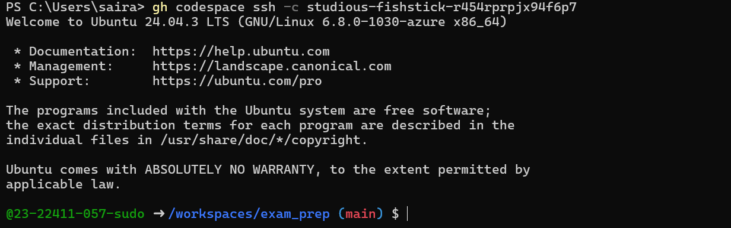

Task 2 — Install AWS CLI inside the Codespace and configure it
- Download and install AWS CLI:
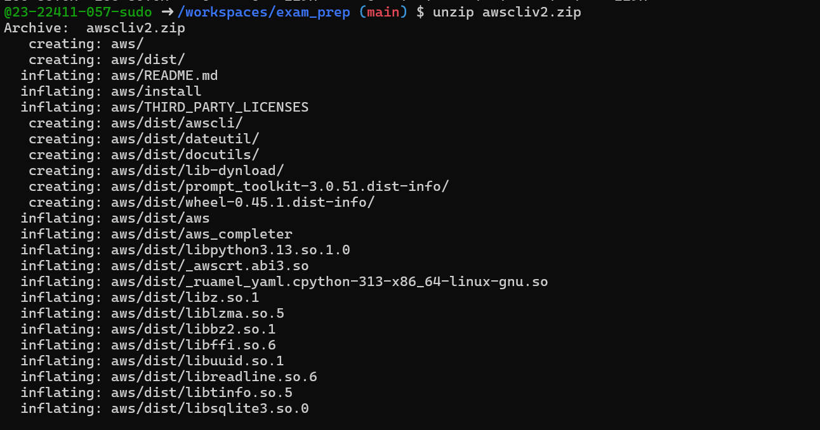
- Verify installation:
- Configure the AWS CLI (you will provide Access Key ID and Secret Access Key for a user with permissions, or use root/IAM user you prepared for the lab):
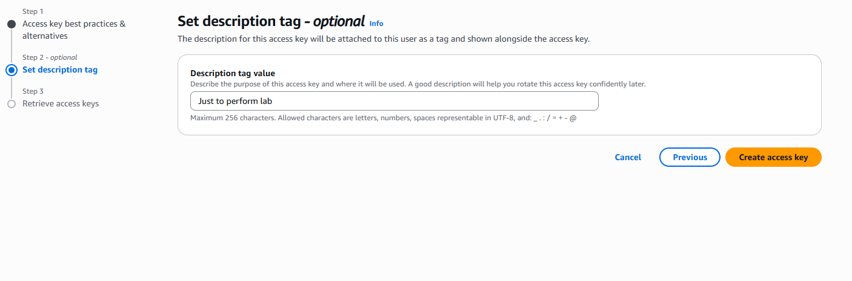
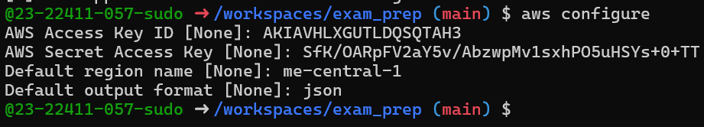
- Verify credentials/config files:

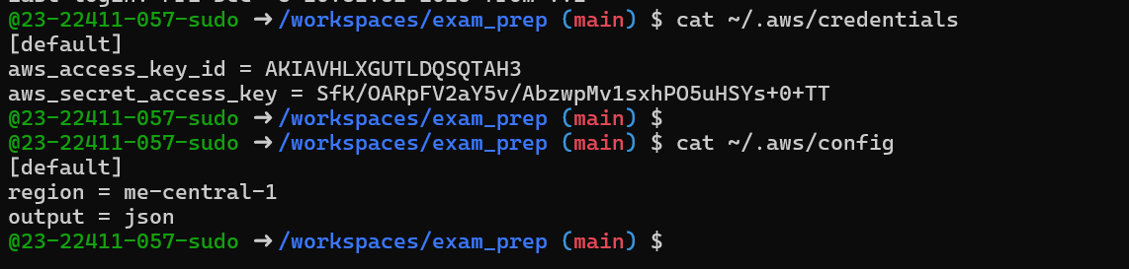
- Verify connectivity (you should see a JSON result showing your caller identity):
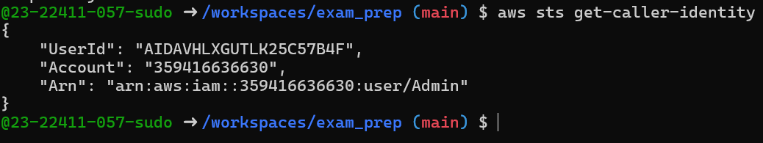

Task 3 — Create security group and add ingress rules using Codespace IP
- Create a security group (substitute your VPC id):
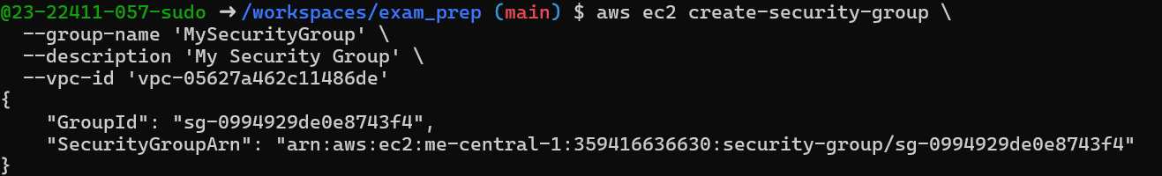
- Inspect the security group (initially ingress will be empty or default):
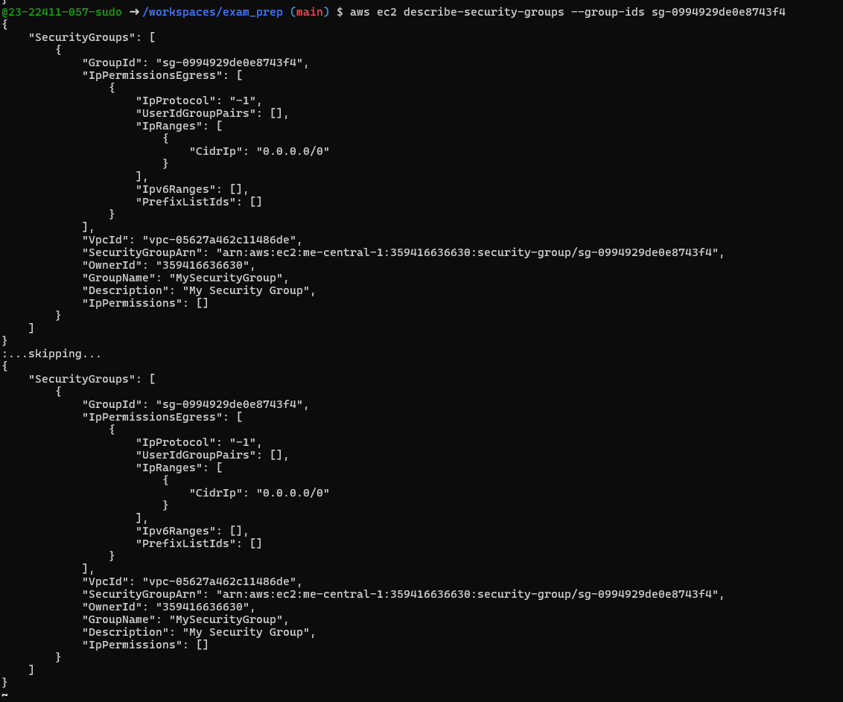
- Get your Codespace public IP (from inside the Codespace):
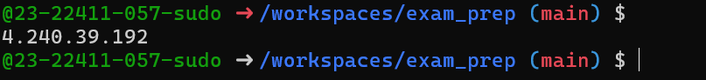
- Authorize SSH inbound on port 22 from your Codespace IP:
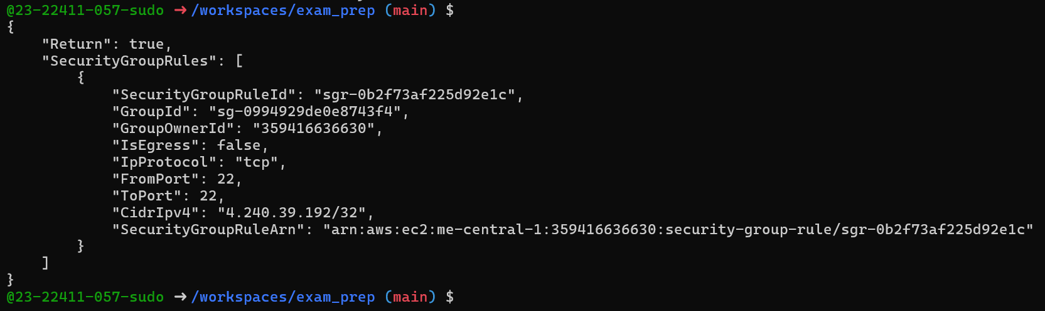
- Verify ingress rule appears:
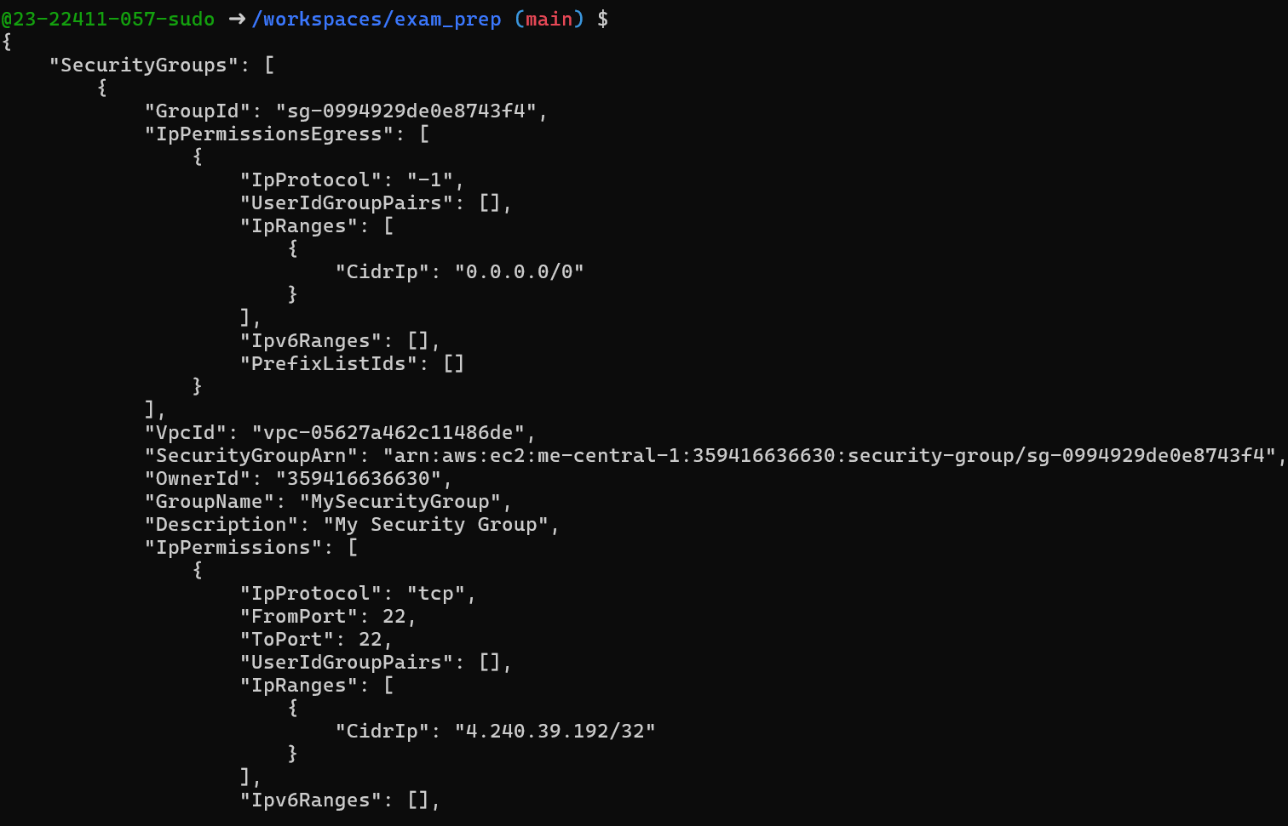
- Add an HTTP rule (port 80) using ip-permissions JSON:
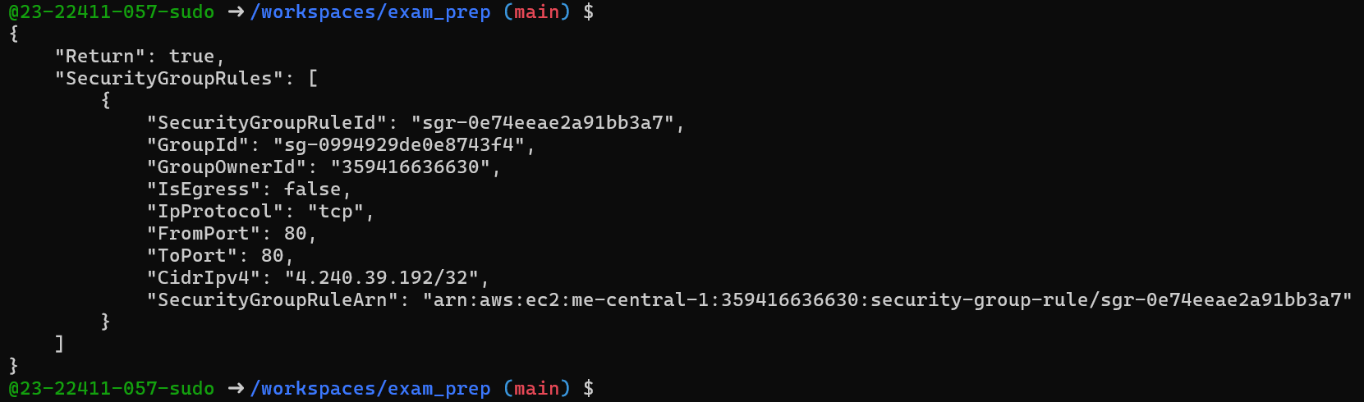
- Verify both ingress rules are present:
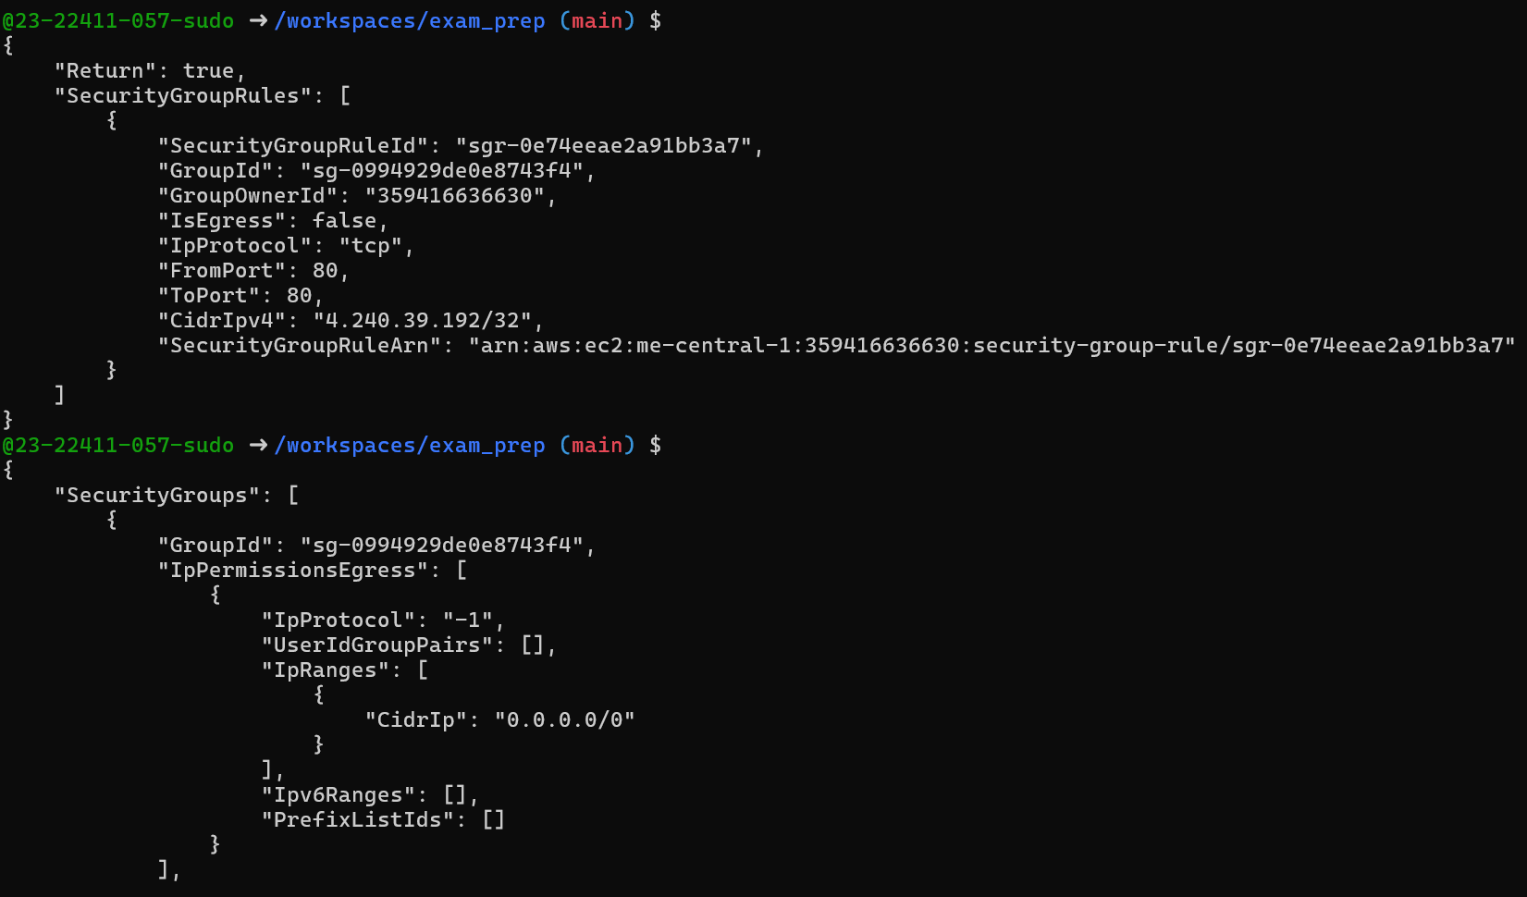
Task 4 — Create a key pair, describe key pairs, and launch EC2 instance
Goal: Create an ED25519 key pair, view it, and launch an EC2 instance using the key pair and the security group created earlier.
Steps:
- Create the key pair and save the PEM file into the Codespace workspace:
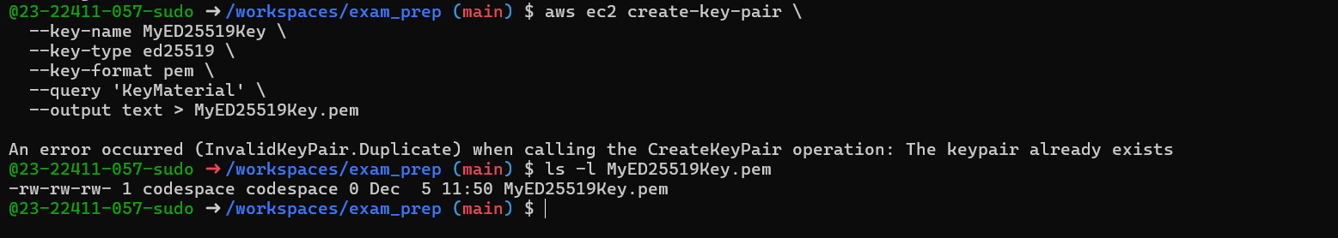
- View created key pairs:
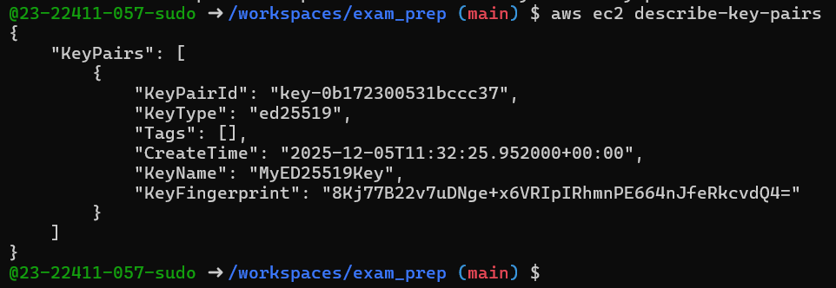
- Launch an EC2 instance (example values — replace IDs with ones from your account/region):

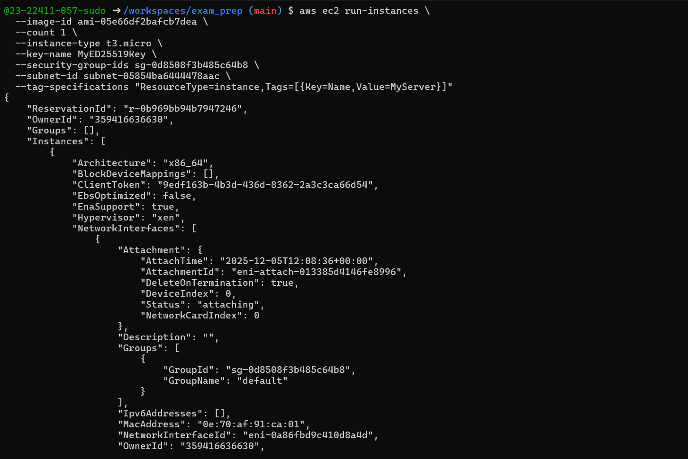
- Get the public IP address of your instance:
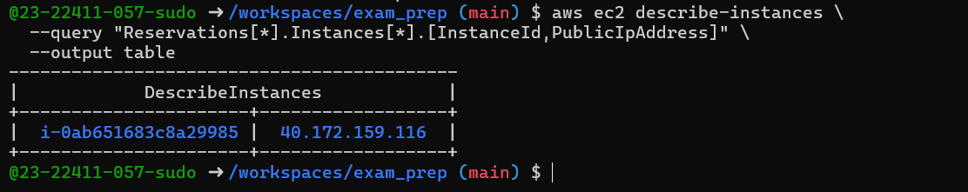
- Attempt SSH into the instance from the Codespace or from a machine whose IP is allowed in the security group:
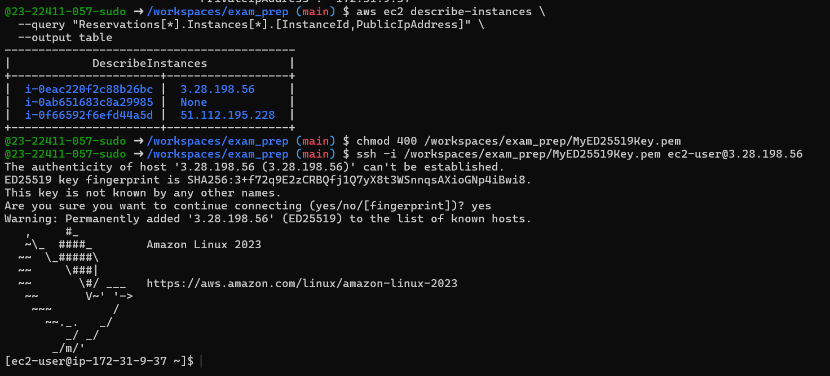
- Stop, start and (optionally) terminate the instance:
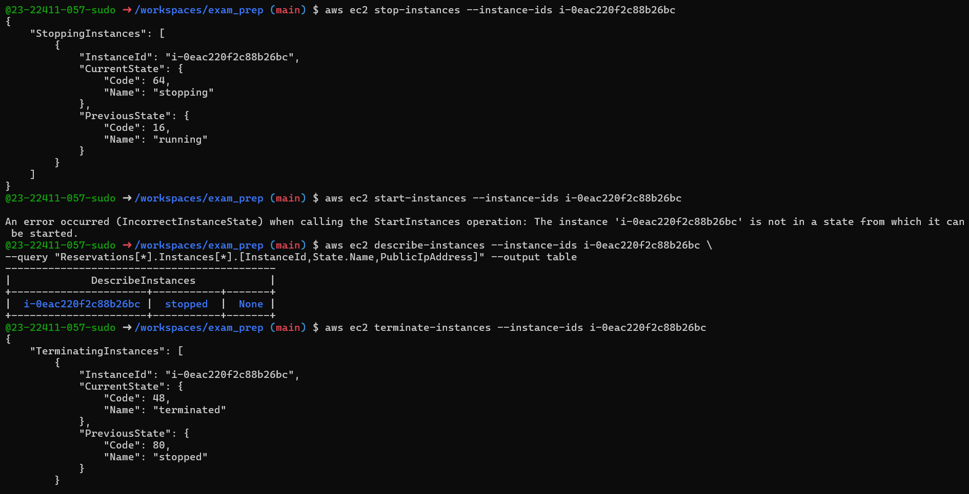
Task 5 — Understand AWS describe-* commands
Goal: Use describe commands to list and inspect AWS resources.
1.Run and understand these commands (run each, then capture screenshot immediately after):
aws ec2 describe-security-groups
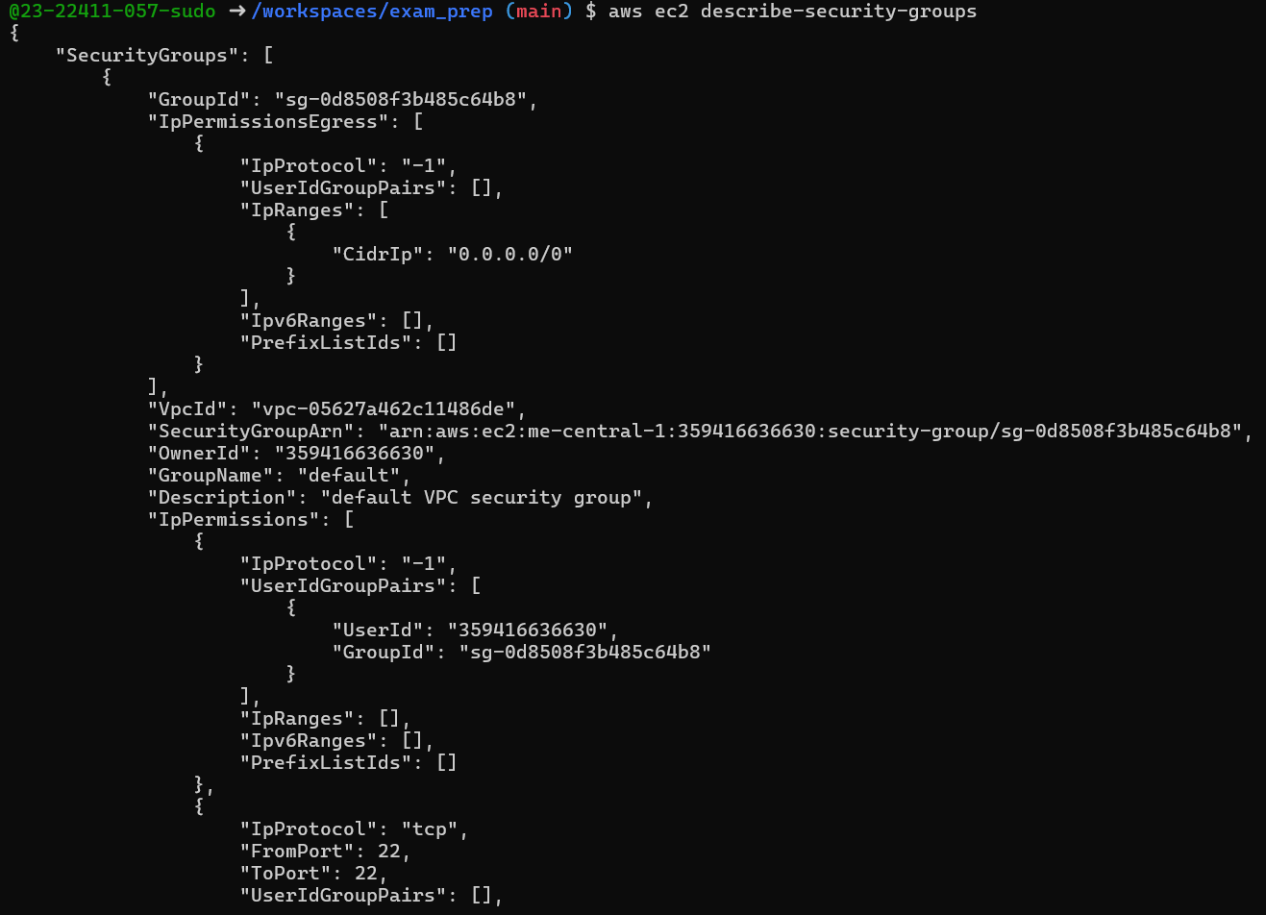
aws ec2 describe-vpcs
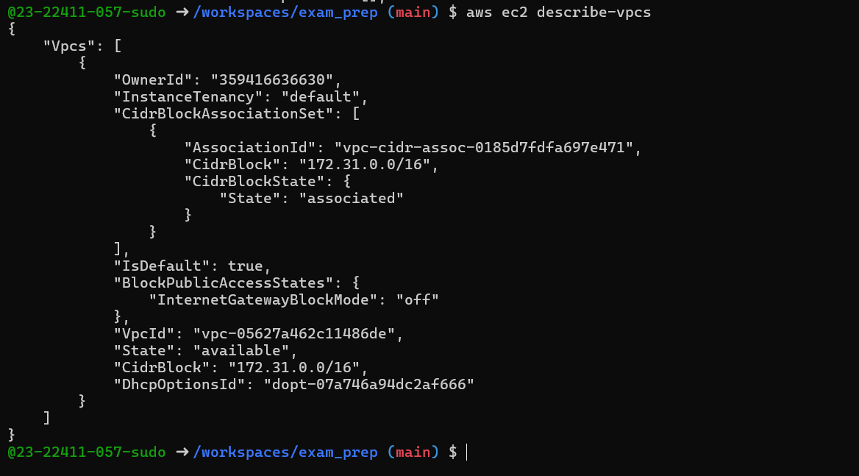
aws ec2 describe-subnets
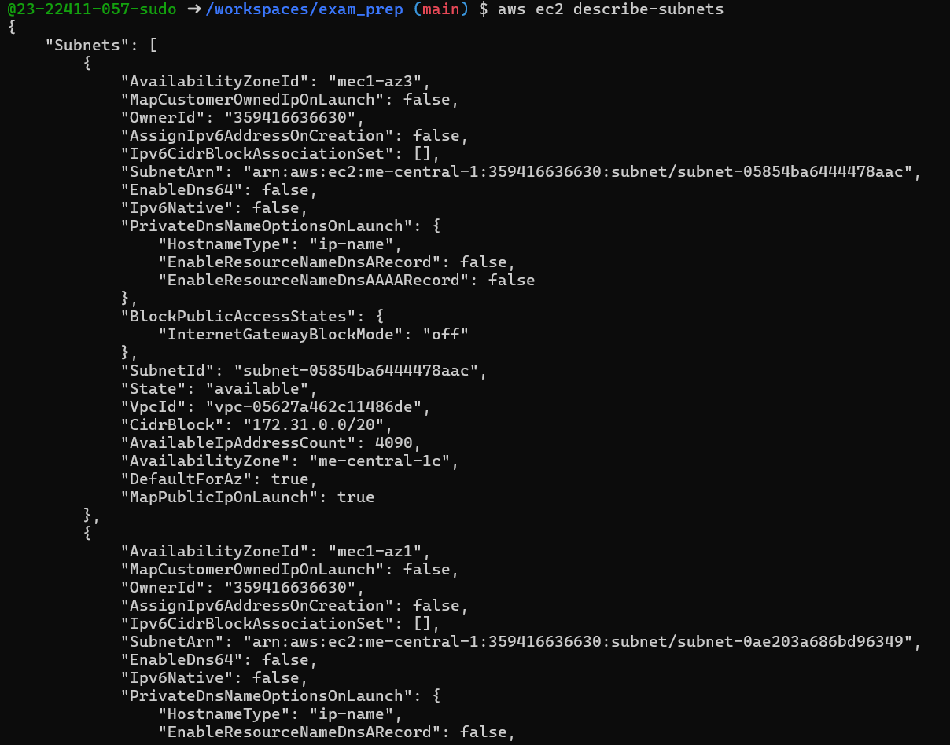
aws ec2 describe-instances
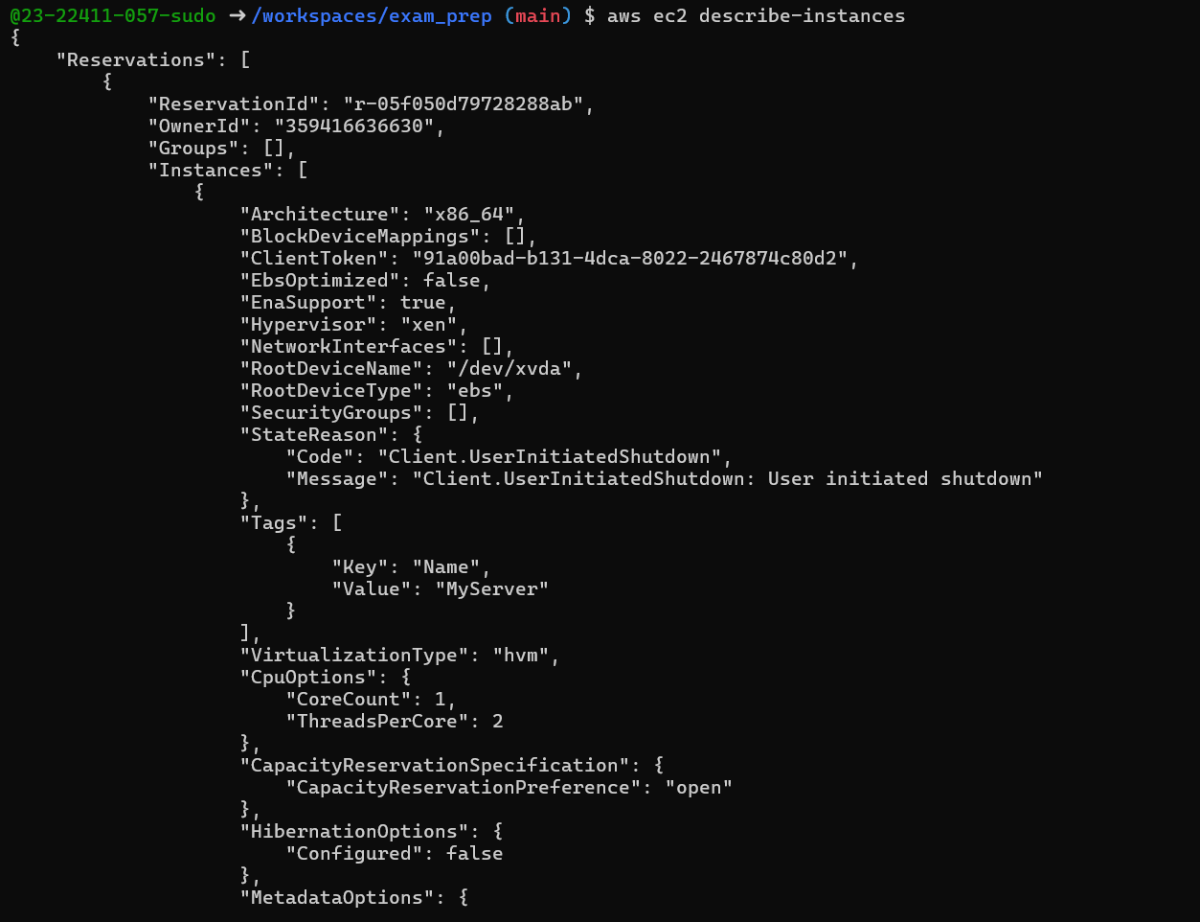
aws ec2 describe-regions
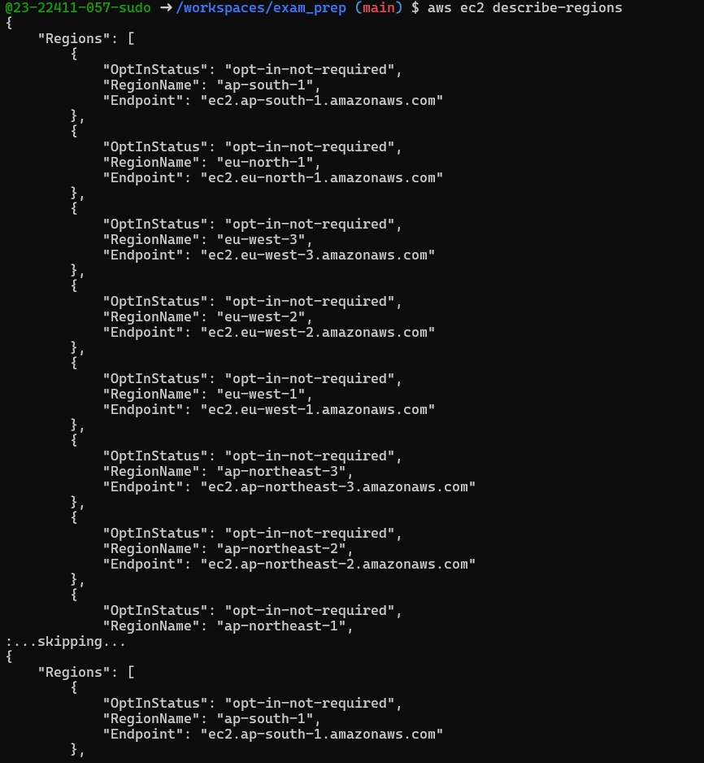
aws ec2 describe-availability-zones
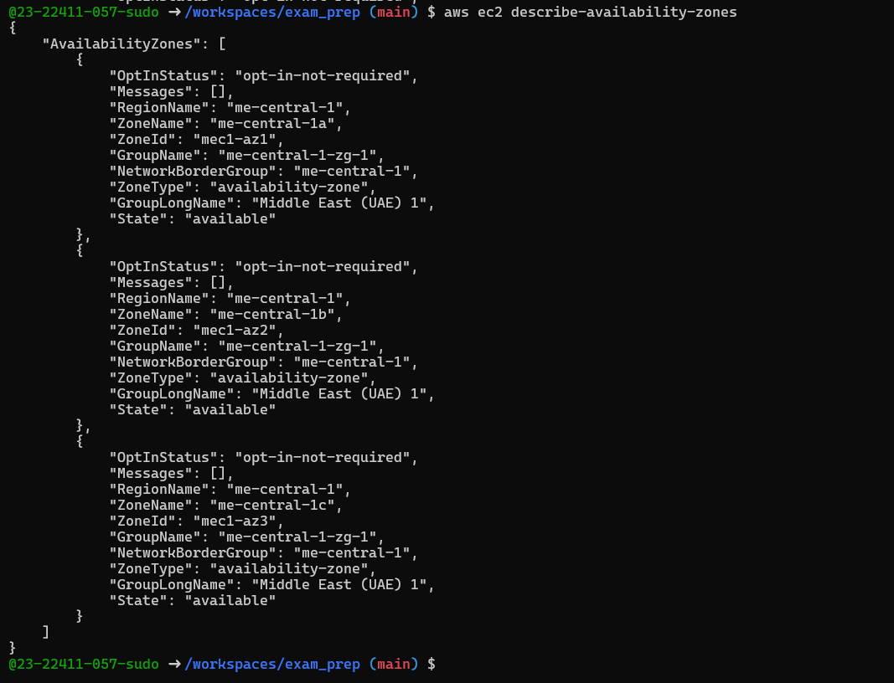

Task 6 — IAM: create group, user, attach policies, create console login & keys
- Create group:
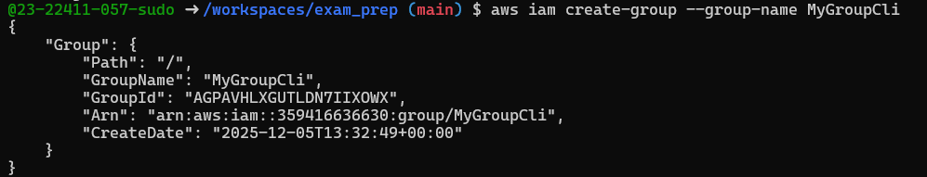
- Get group details:
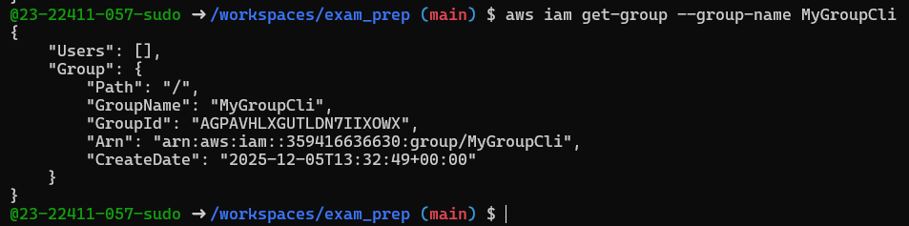
- Create user:
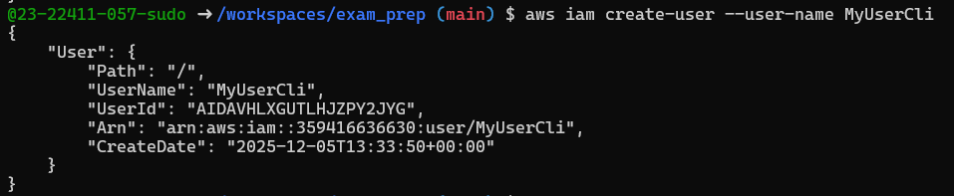
- Get user details:
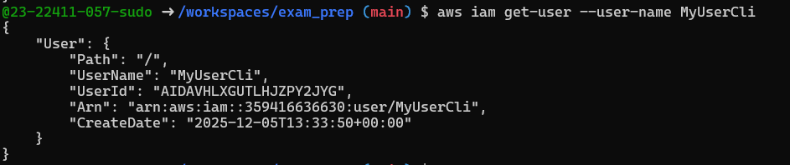
- Add user to group:
- See group again:
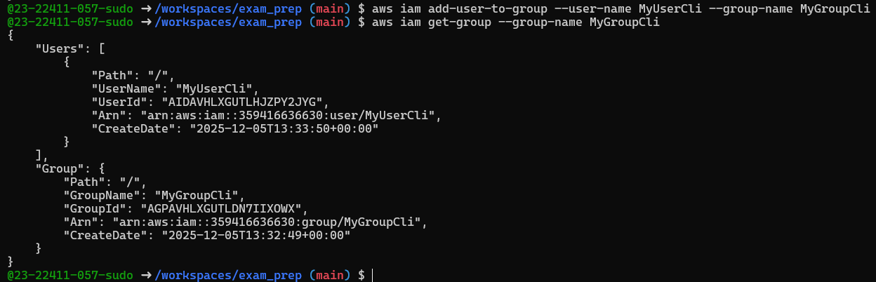
- List policies that mention EC2:
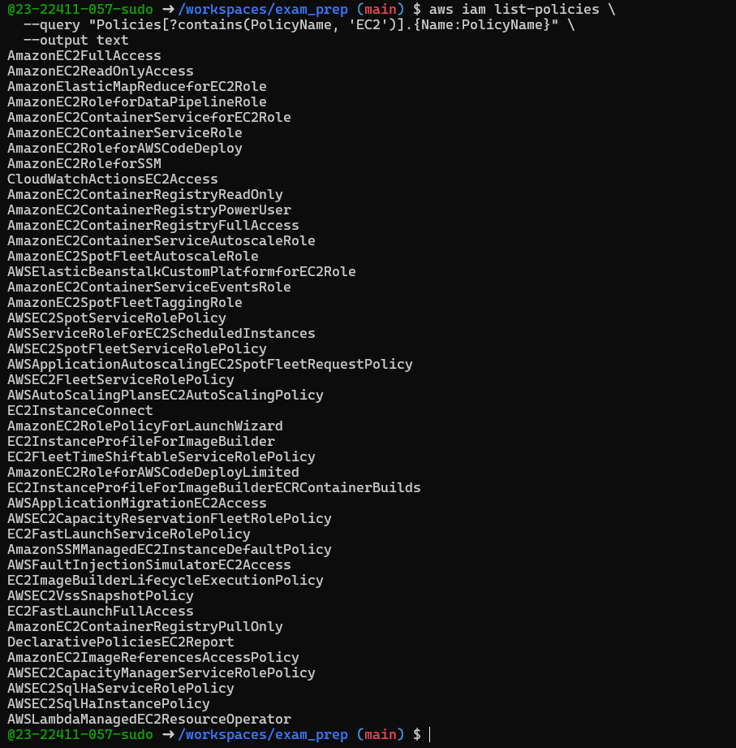
- Get ARN for AmazonEC2FullAccess (example query):
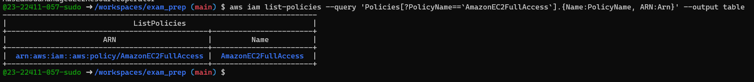
- Attach policy to group (use the ARN you retrieved):
- List attached policies for the group:

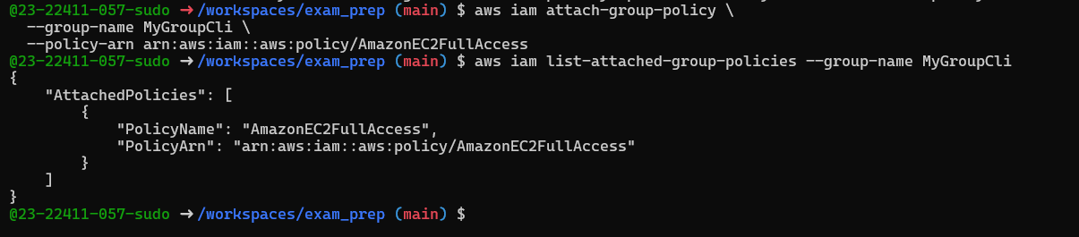
- Create a console login profile for the user:
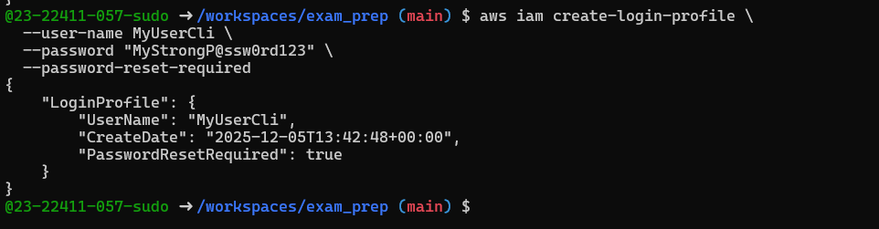
- If the user cannot change password, attach IAMUserChangePassword to the group temporarily:
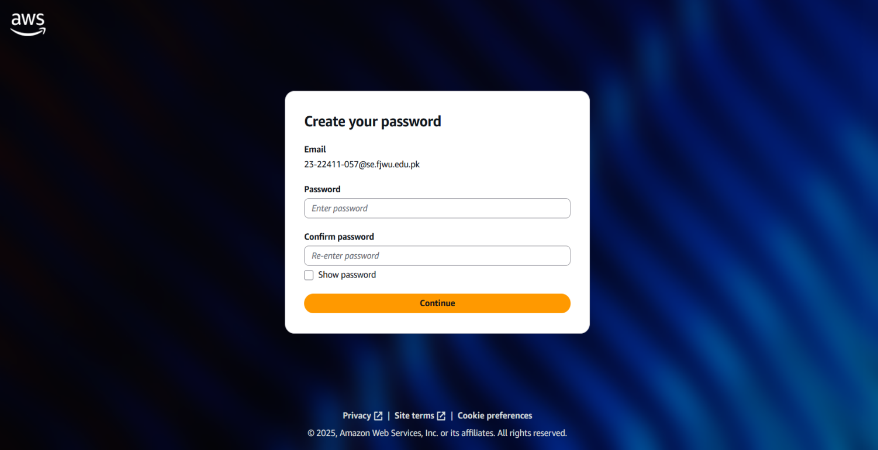
- Create access keys for the user (save AccessKeyId and SecretAccessKey securely):
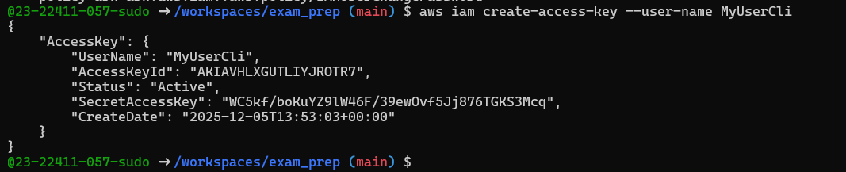
- List access keys:
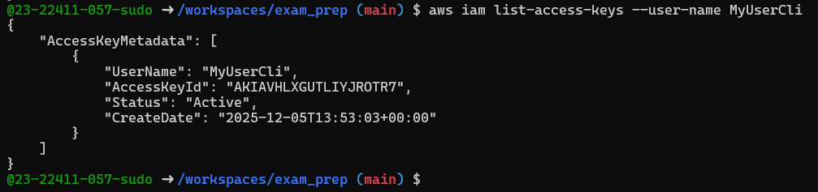
- (Don't) Delete access key:
- Use environment variables to authenticate as that user in the Codespace:
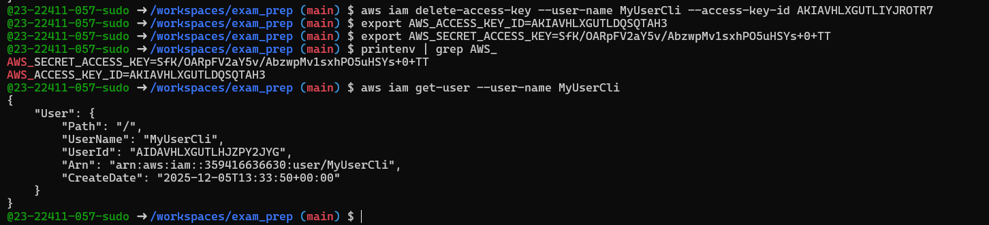

Task 8 — Use --query to format outputs for reporting
Goal: Extract useful fields in table format for reporting.
Examples (run each and take a screenshot immediately after):
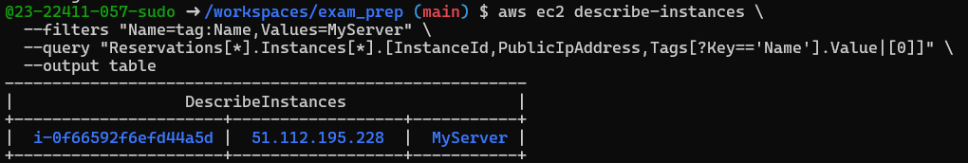
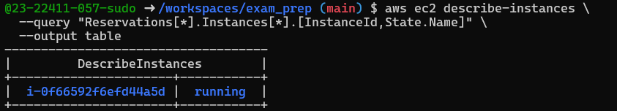
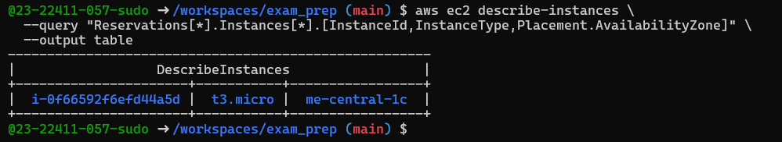

Cleanup — Remove resources to avoid charges
- Terminate instances:
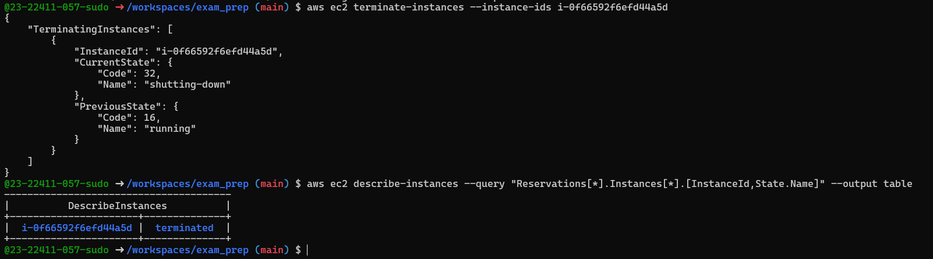
- Delete EBS Volumes (if any)
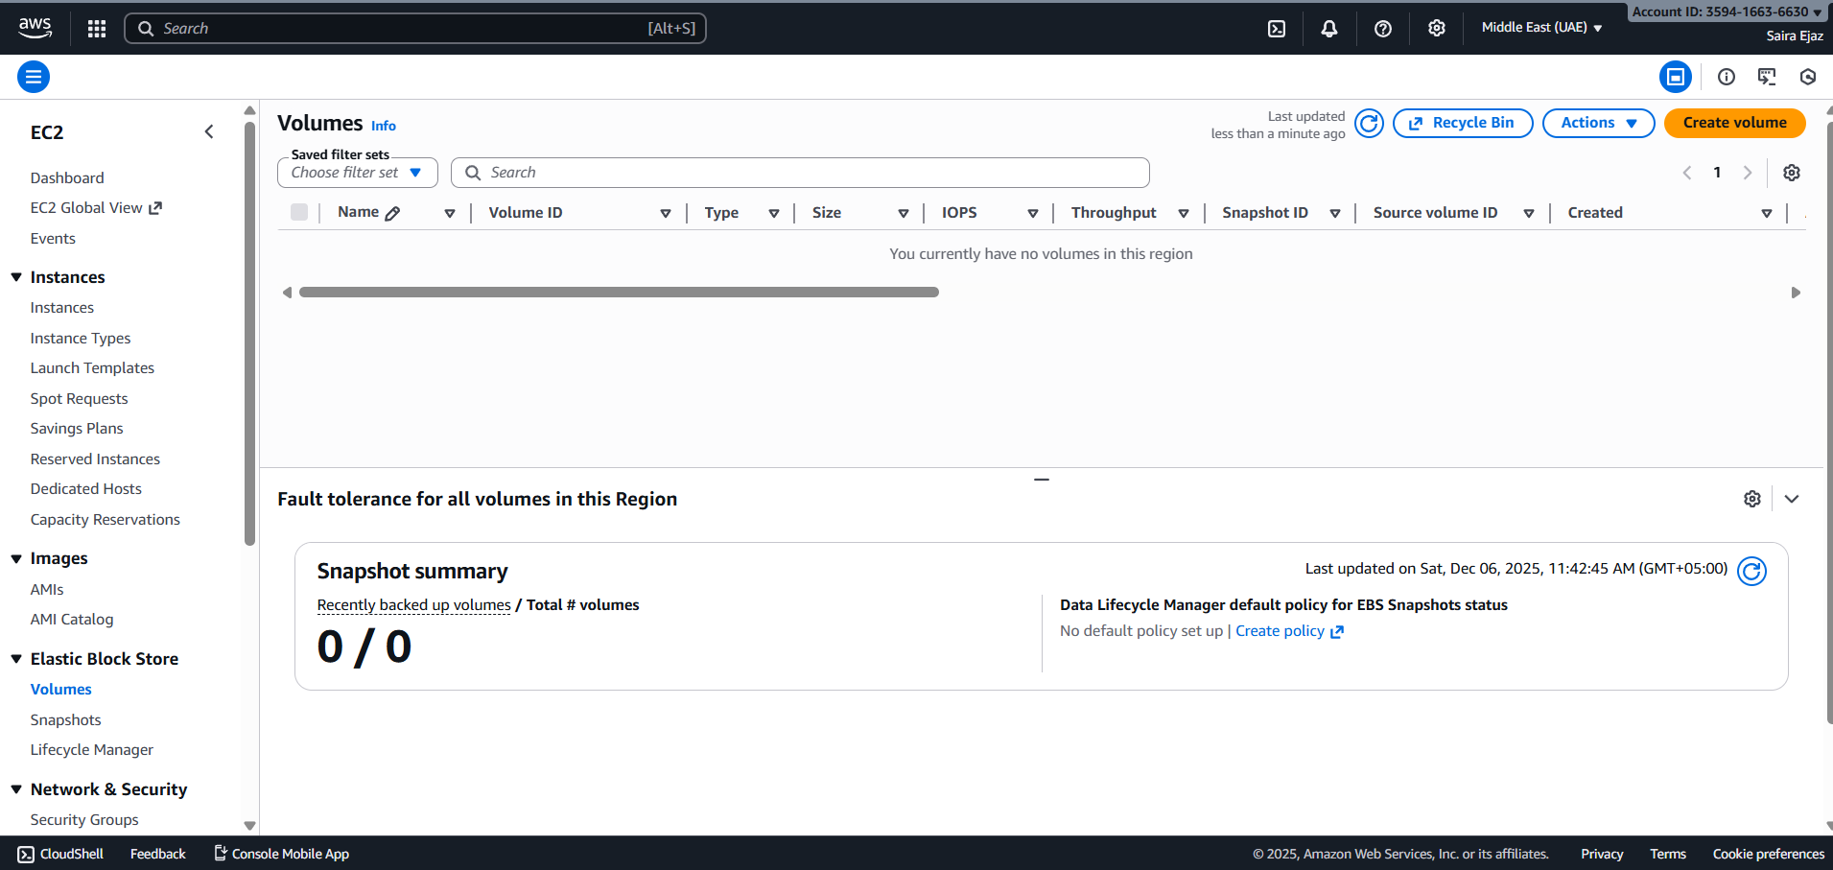
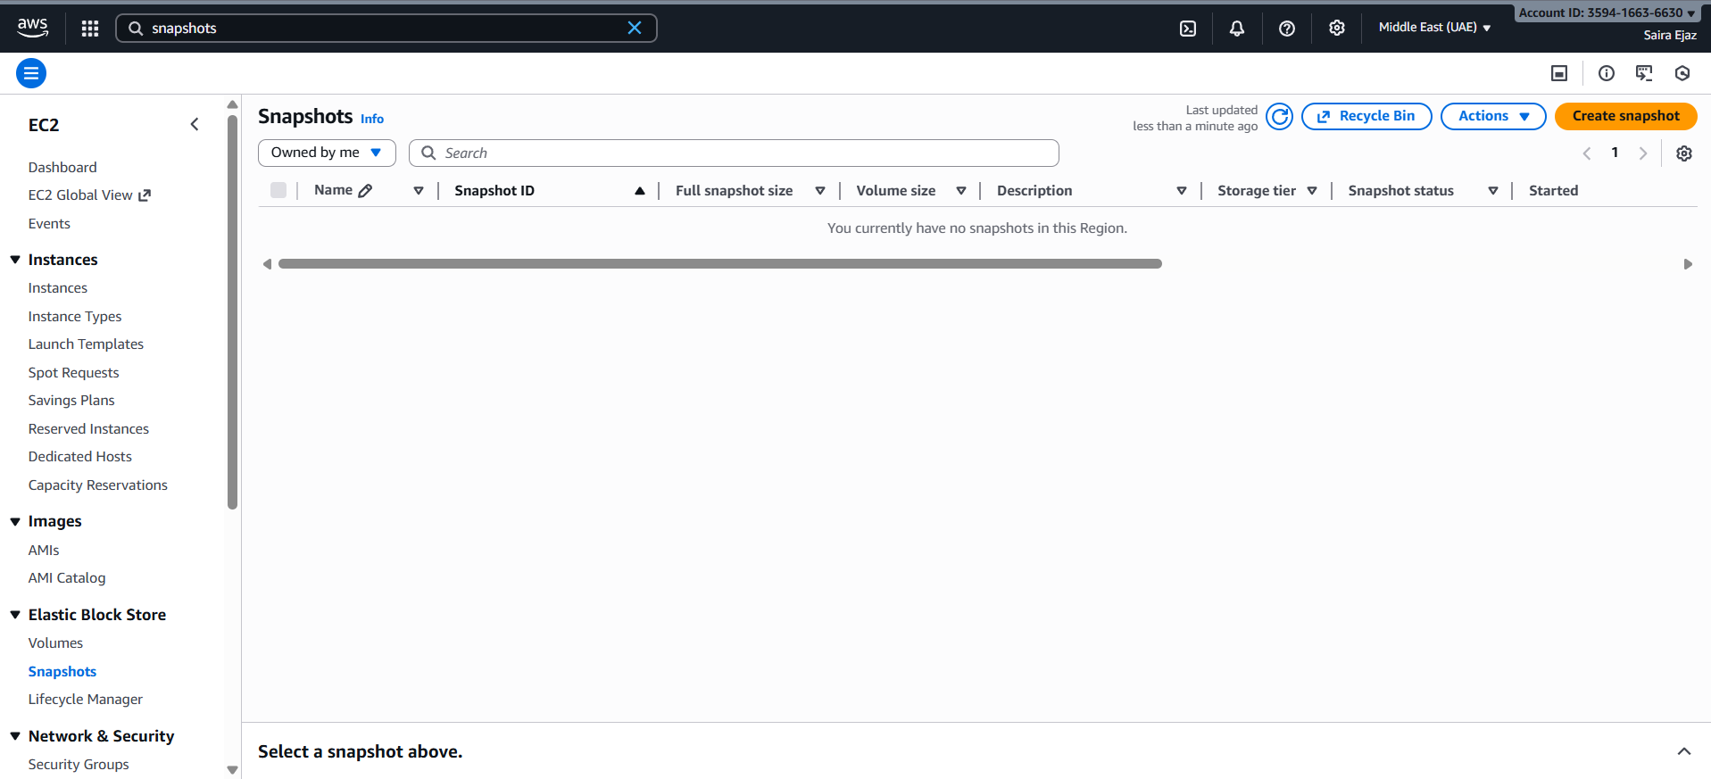
- Delete security group and key pair:
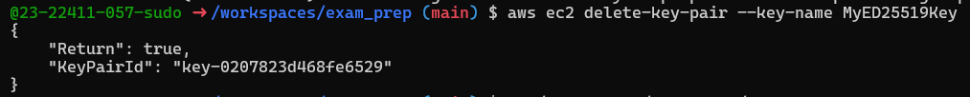
- Remove IAM users, access keys, groups:
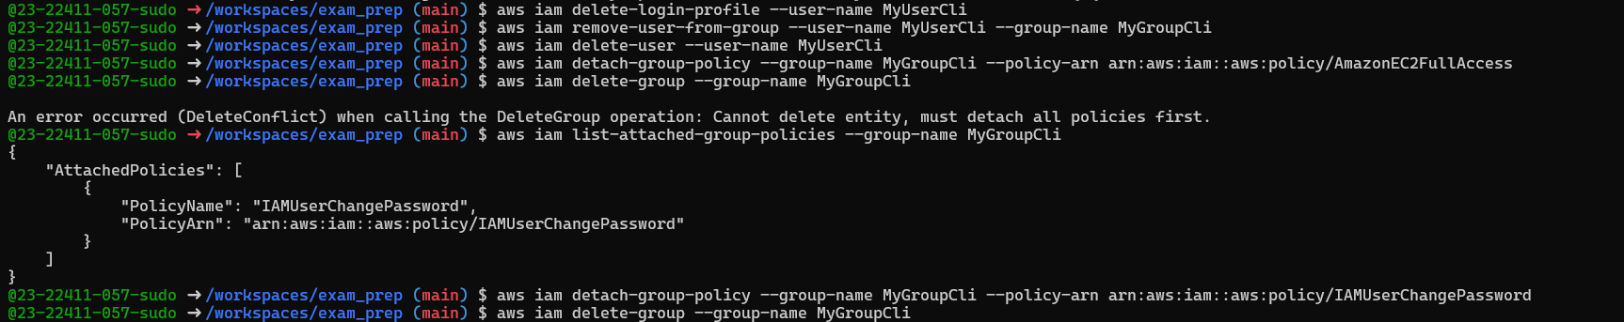
- Clean Summary
